Object Oriented Programming
15-3-26
Aim – Demonstrate OOP in python.
Theory – Object-Oriented Programming in Python organizes code using classes and objects. A class defines attributes and methods, while objects are instances of classes. Inheritance allows new classes to reuse properties from parent classes. Method overriding enables subclasses to modify behavior. This approach improves modularity, reusability, and structure of programs.
A1.
class Animal:
def __init__(self, name):
self.name = name

def speak(self):
print(f"{self.name} makes a sound.")

class Dog(Animal):
def speak(self):
print(f"{self.name} barks.")

class Cat(Animal):
def speak(self):
print(f"{self.name} meows.")

# Creating objects
dog = Dog("Buddy")
cat = Cat("Whiskers")

# Accessing attributes and methods
print(dog.name)
dog.speak()

print(cat.name)
cat.speak()
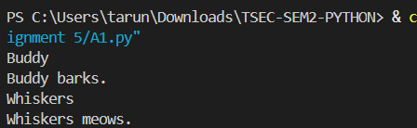

Conclusion
This program demonstrates inheritance and polymorphism where Dog and Cat override the speak method of the Animal class.

